# Least Square Method

**Key Formulas**

1. **Regression Line Equation**

Y = mx + b

m: slope

b: intercept

1. **Slope(m):**

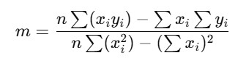

1. **Intercept(b):**



1. **Prediction:**



1. **Residuals (Error):**



1. **Mean Squared Error (MSE):**



# Gradient Descent

**Key Formulas**

1. **Regression Line Equation:**

y=mx+b

1. **Cost Function (Mean Squared Error):**

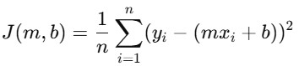

1. **Gradients (Partial Derivatives):**

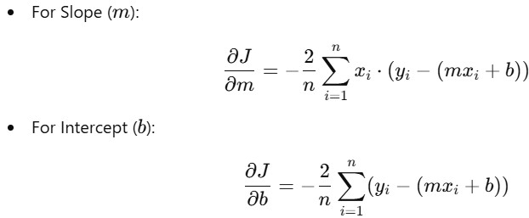

1. **Update Rules:**

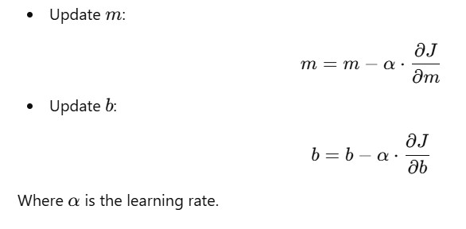

# Normal Equation

